# A CRM APPLICATION FOR SCHOOLS AND COLLEGES

# INTRODUCTION

# OVERVIEW

A CRM application for schools will be very much helpful for maintaining huge records of the students in cloud and data can be manipulated by school authorities for the betterment of the students and for the possible communication of parents .

# PURPOSE

AN education CRM system specifically tailored for the educational institute ,colleges, and other educational organizations to manage the whole process, from inquiry to enrollment to alumni and beyond.

CRM systems used to automate and handle communications with prospective and current students, teachers,employees,organizations,donors,and everyone in your organizations community.

Customer relationship management solutions are required in the education sector to make fast, dynamic, and affordable solutions that make it easy for universities to handle daily activities. The CRM gives a proper understanding of the students and activities carried out in the university. It also lets students communicate with the university.

In a custom CRM for a university, students get information about enrollment, registration, financial help, accommodation, and so on. They are considered as the customers, and the goal is to provide top-quality services to students.

With CRM solutions, universities can manage their students effectively. CRM also collects the management records such as student attendance, course curriculum, extracurricular activity records, and so on. It also maintains data privacy by automating processes. By analyzing the CRM information, solutions to problems can be found.

A CRM increases productivity, allows communication between students and alumni, and reduces administrative tasks in the education industry. Eventually, it helps the institute to establish itself as a brand in the crm.

# 2 PROBLEM DEFINITION AND DESIGN THINKING

# 2.1 EMPATHY MAP

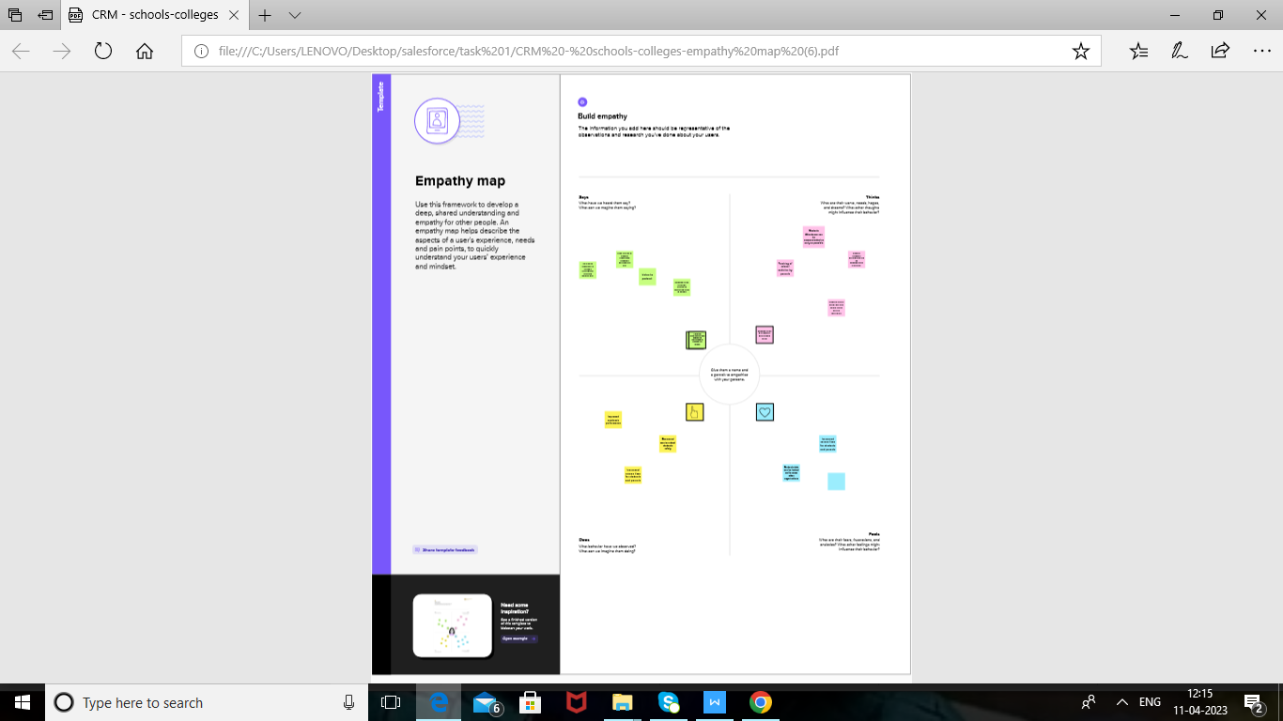

# 2.2 IDEATION AND BRAINSTORMING MAP

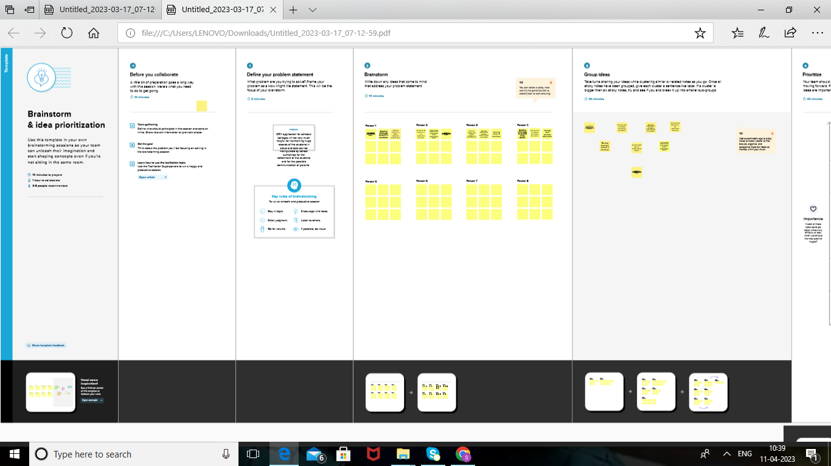

# 3 RESULT

# 3.1 DATA MODEL

|  |  |
| --- | --- |
| OBJECT NAME | FIELD IN THE OBJECT |
| SCHOOL | |  |  | | --- | --- | | FIELD LABEL | DATA TYPE | | ADDRESS | TEXT AREA | | DISTRICT | TEXT AREA | | STATE | TEXT AREA | | SCHOOL WEBSITE | TEXT AREA | | PHONE NUMBER | PHONE | |
| STUDENT | |  |  | | --- | --- | | FIELD LABEL | DATA TYPE | | STUDENT NAME | TEXT AREA | | CLASS | NUMBER | | SCHOOL | TEXT AREA | | PHONE NUMBER | PHONE | | RESULT | PICK LIST | |
| PARENTS | |  |  | | --- | --- | | FIELD LABEL | DATA TYPE | | PARENT NAME | TEXT AREA | | STUDENT NAME | TEXT AREA | | CLASS | NUMBER | | SCHOOL | TEXT AREA | | ADDRESS | TEXT AREA | | PHONE NUMBER | PHONE | |
| PRINCIPAL |  |
| TEACHER |  |

# 3.2 ACTIVITY AND SCREENSHOT

### **Creation Of School Object**

Creation of Objects for School Management:

For this school management we need to create 3 objects i.e school,parents and students.

STEP 1

Click on the gear icon and then select Setup.

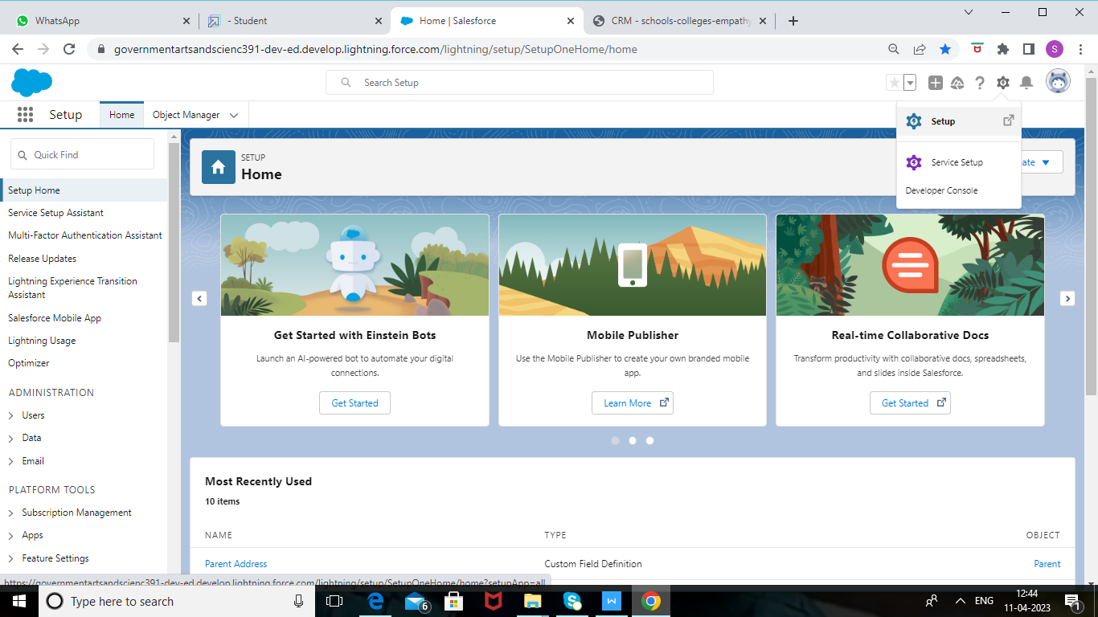

 STEP 2

Click on the object manager tab just beside the home tab.

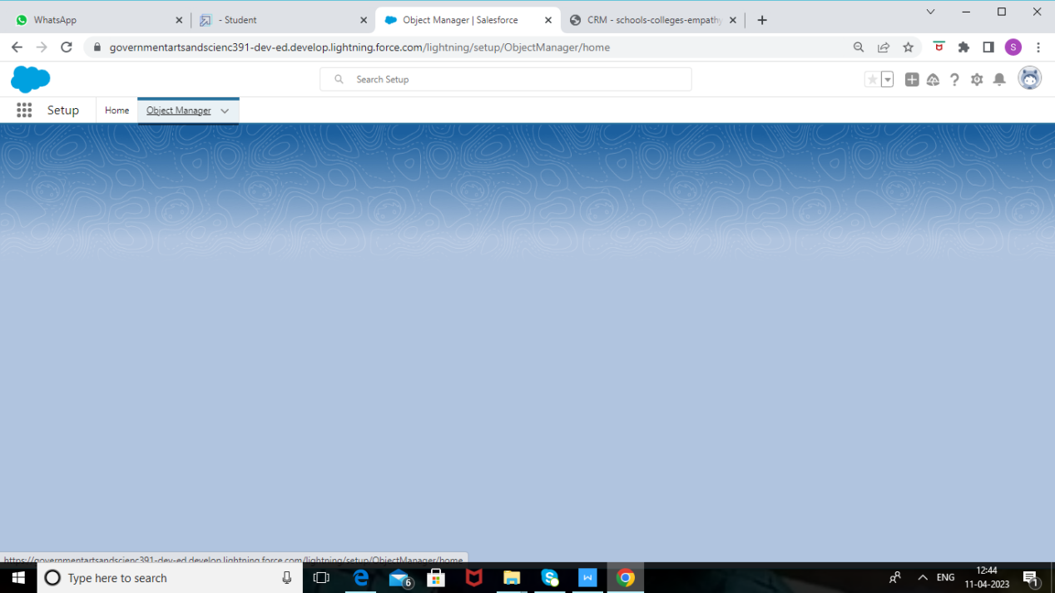

 After the above steps, have a look on the extreme right you will find a Create Dropdown

click on that and select Custom Object.

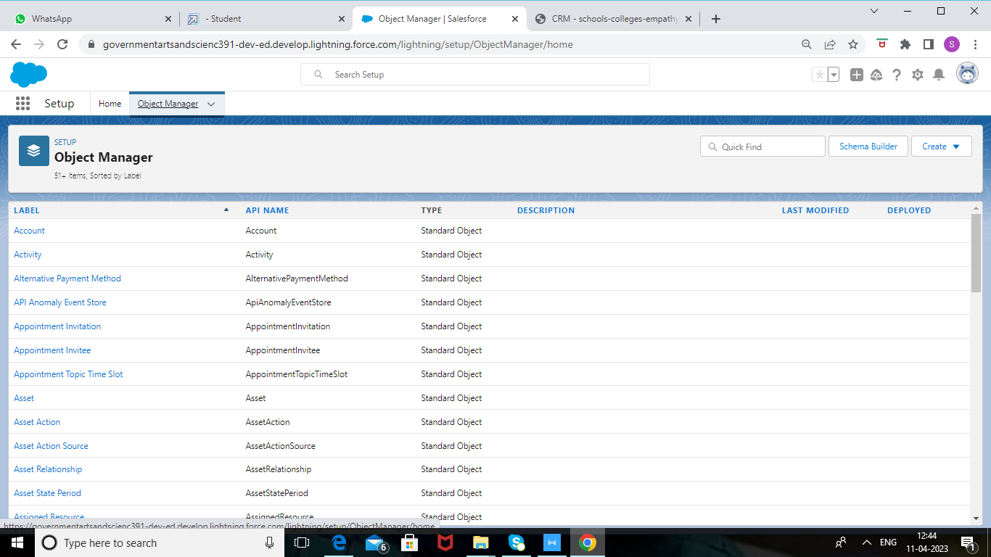

STEP 3

 On the Custom Object Definition page, create the object as follows:

b. Label: School

c. Plural Label: Schools

d. Record Name: School Name

e. Check the Allow Reports checkbox

f. Check the Allow Search checkbox

g. Click Save.

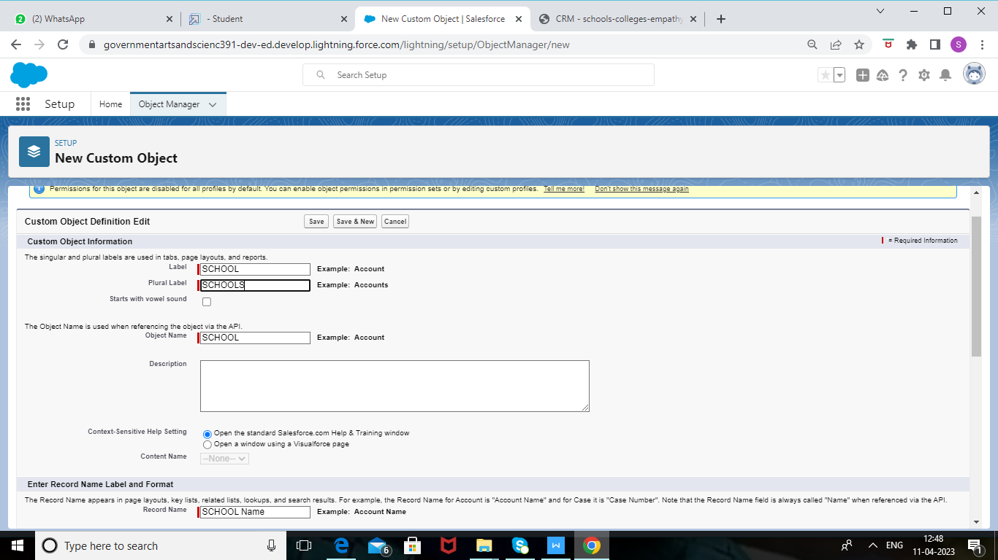

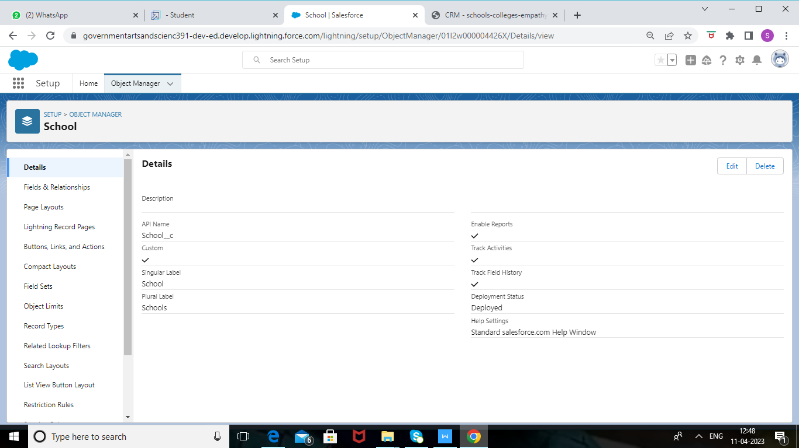

### **Create Student Object**

STEP 1

Click on the gear icon and then select Setup.



STEP 2

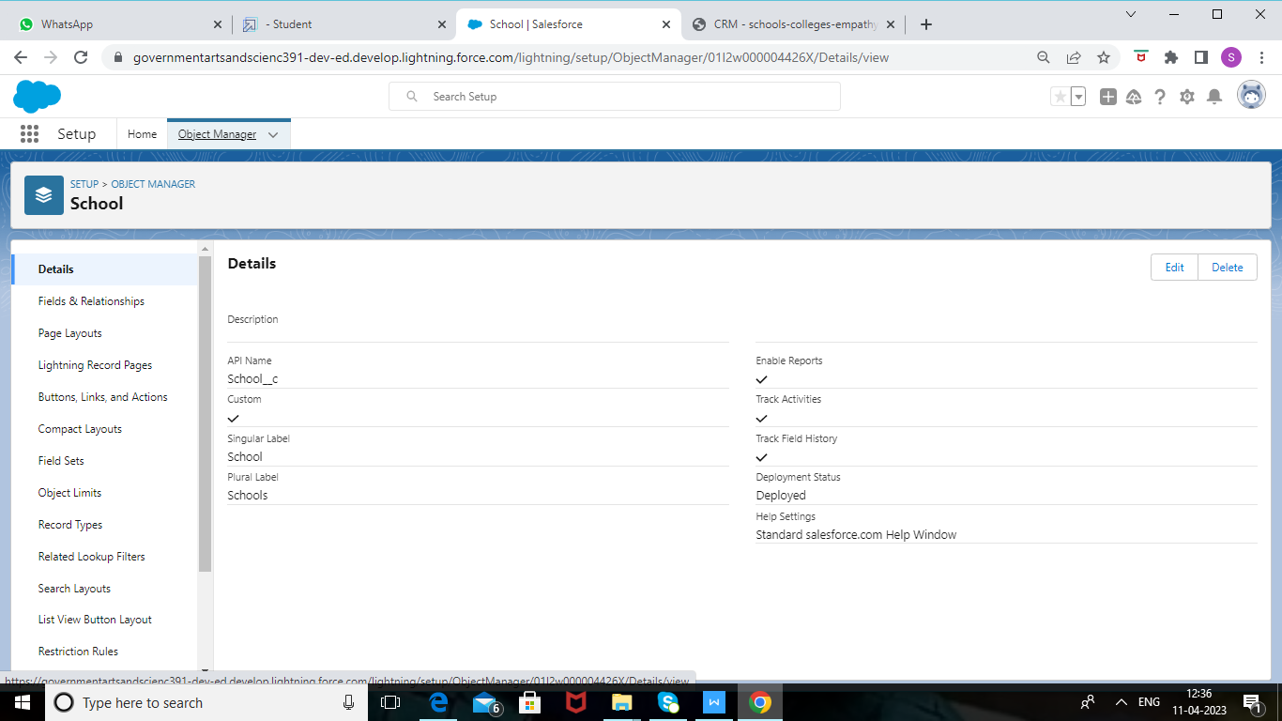 Click on the object manager tab just beside the home tab.

STEP 3

 After the above steps, have a look on the extreme right you will find a Create Dropdown

click on that and select Custom Object.

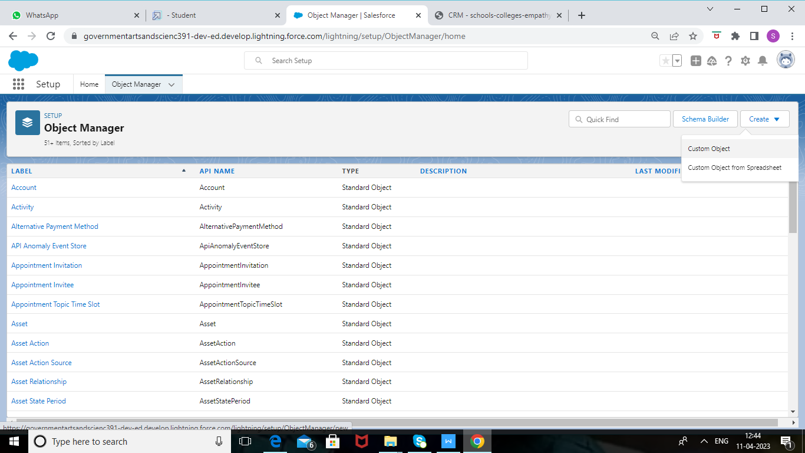

a. On the Custom Object Definition page, create the object as follows:

b. Plural Label: Students

c. Record Name: Student Name

d. Check the Allow Reports checkbox

e. Check the Allow Search checkbox

f. Click Save.

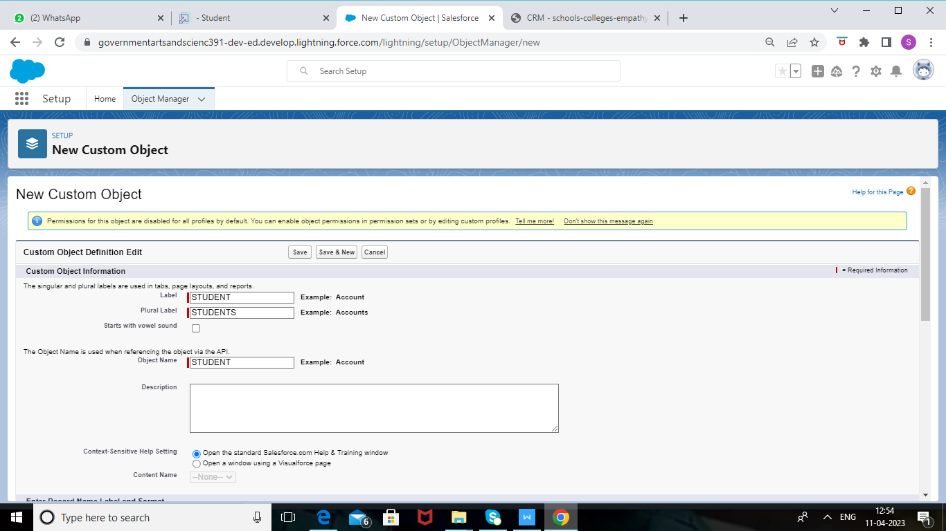

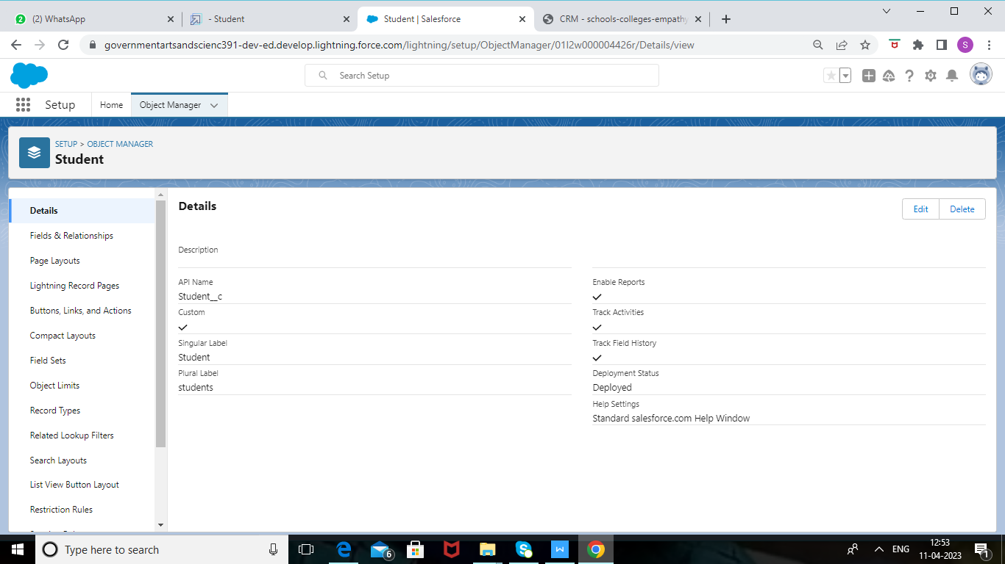

### **Create Parent Object**

STEP 1

1. Click on the gear icon and then select Setup.

2. Click on the object manager tab just beside the home tab.

3. After the above steps, have a look on the extreme right you will find a Create Dropdown

click on that and select Custom Object.

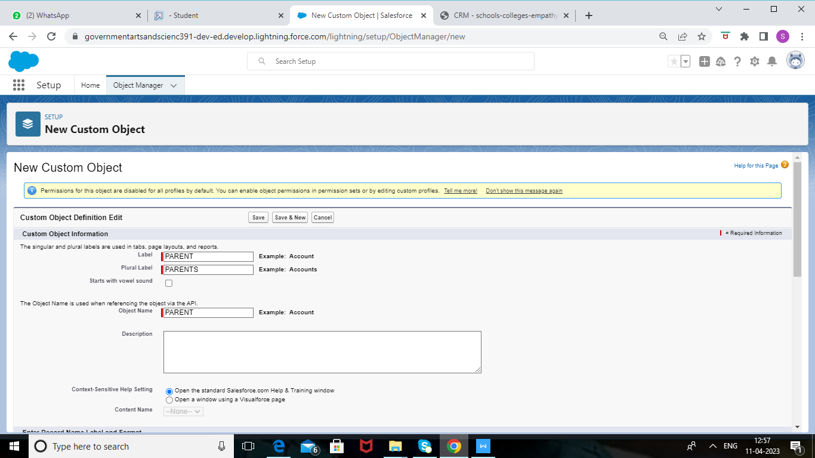

-

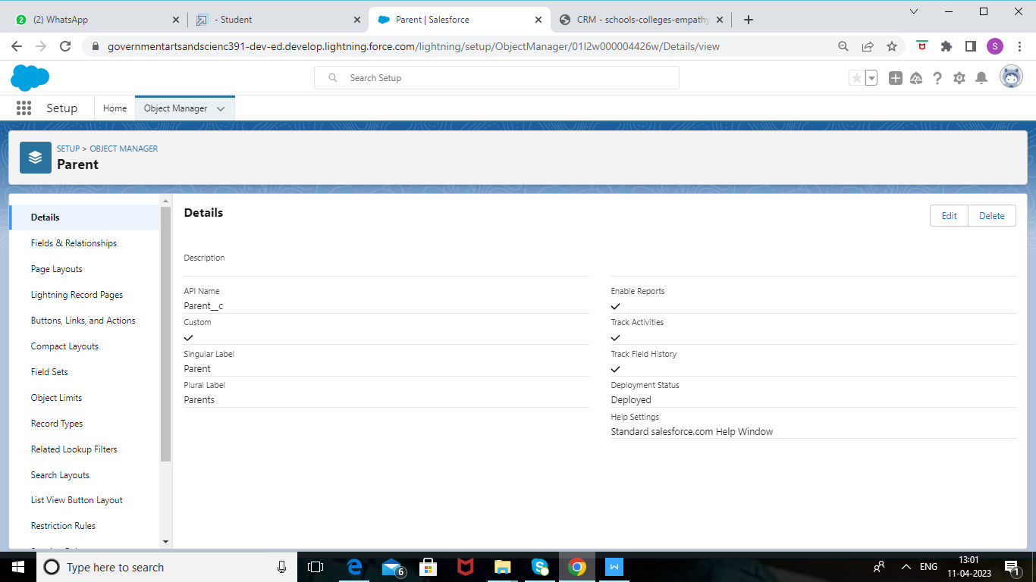

### **Create The School Management App**

STEP 1

From Setup, enter App Manager in the Quick Find and select App Manager.

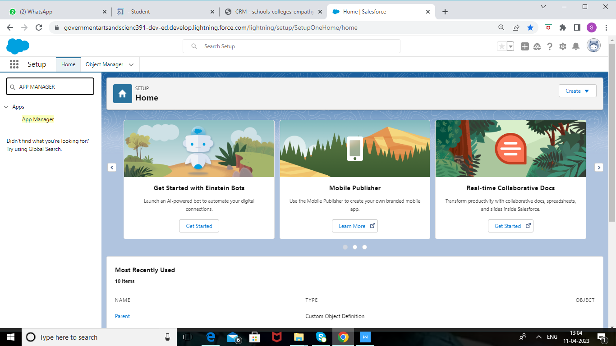

STEP 2

Click New Lightning App. Enter School Management as the App Name, then click Next

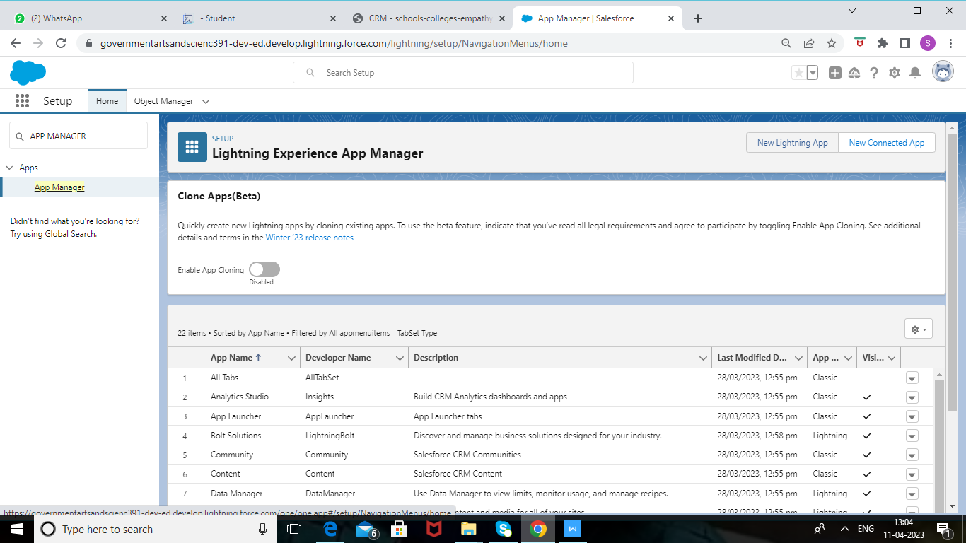

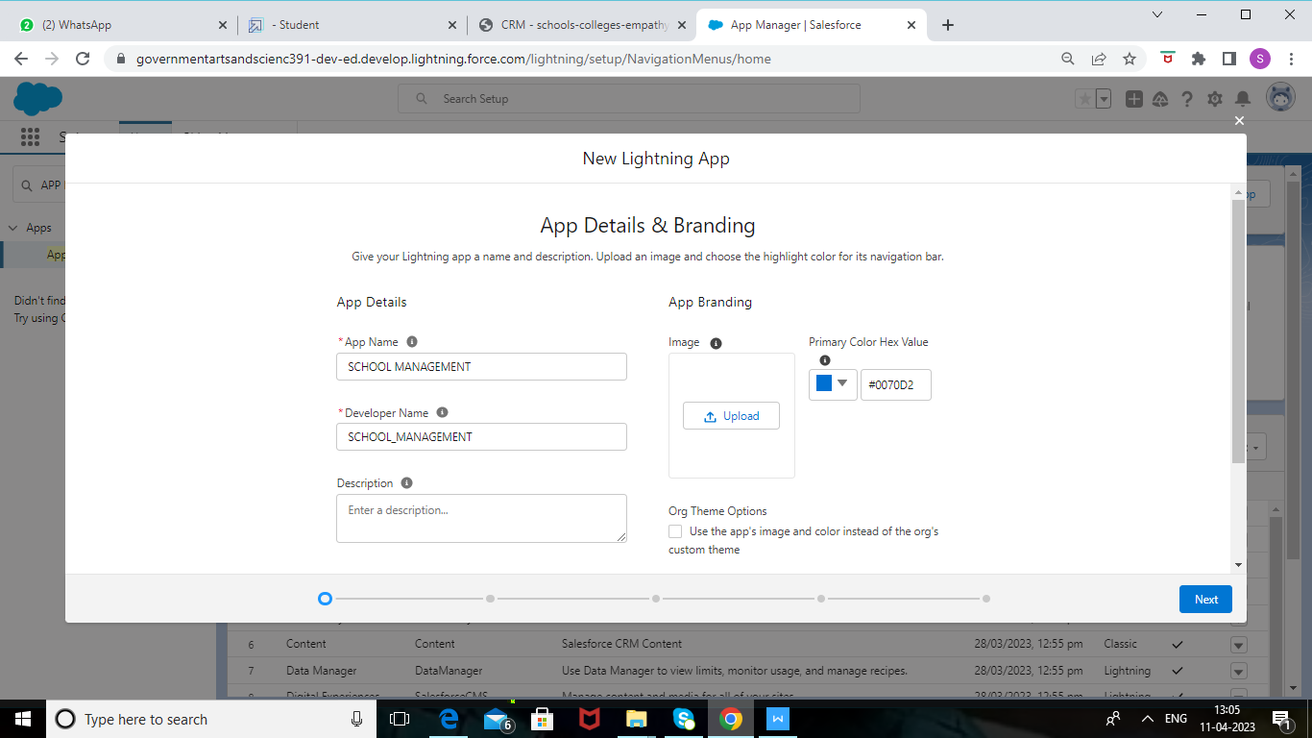

Under Utility Items, leave as is and click Next.

From Available Items, select Schools, Students, Parents, Reports, and Dashboards and move them to Selected Items. Click Next.

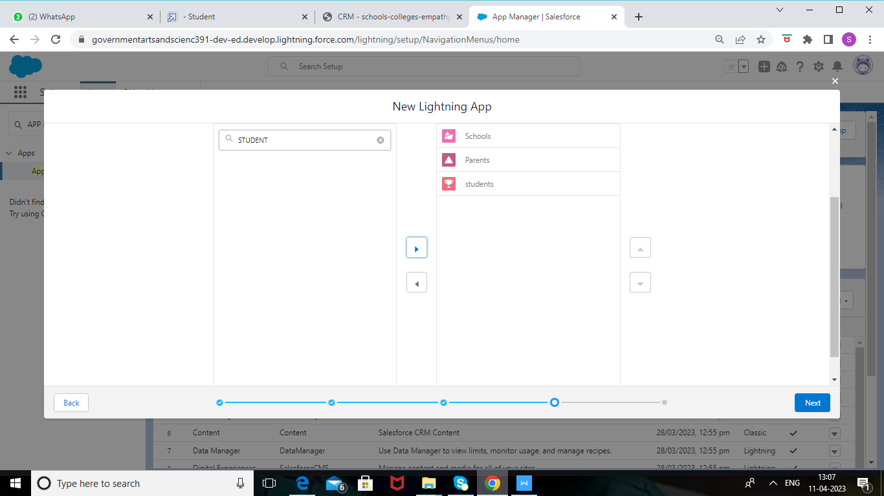

From Available Profiles, select System Administrator and move it to Selected Profiles.

Click Save & Finish.  
  
 To verify your changes, click the App Launcher, type School Management and select the

School Management app.

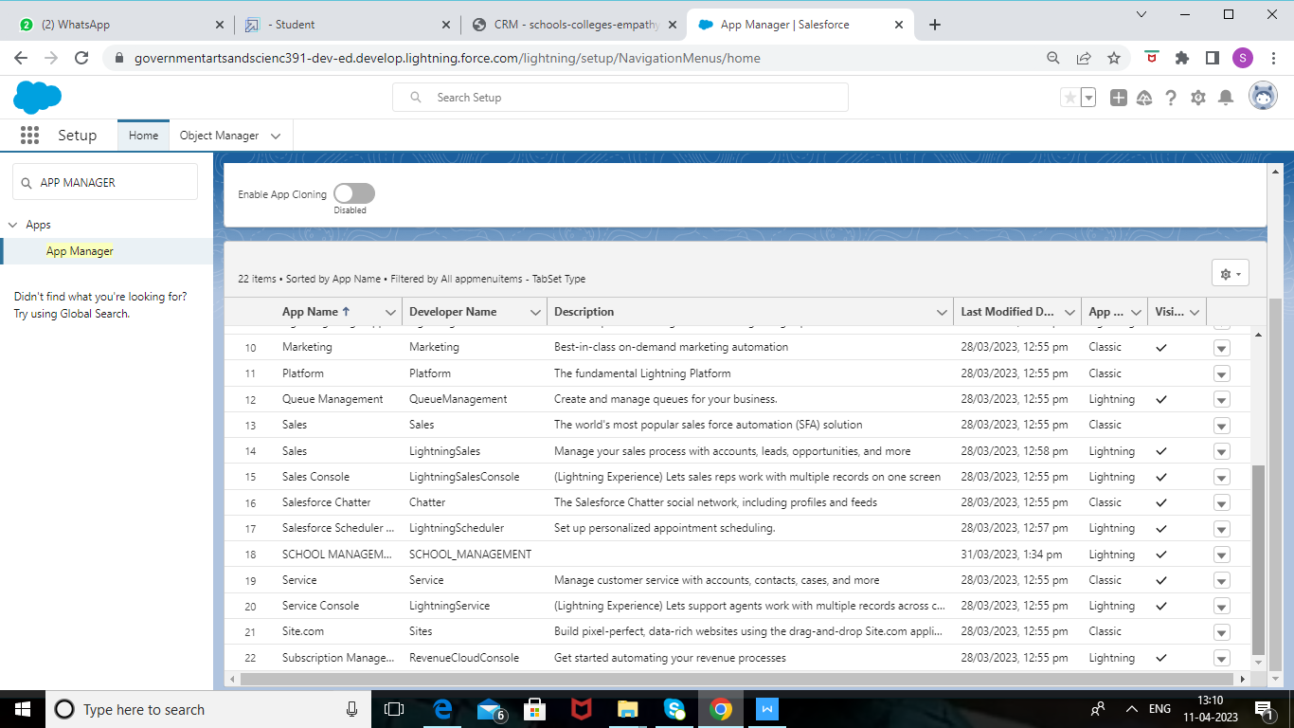

### **Creation Of Fields For The School Objects**

**Step 1**

click the gear icon and select Setup. This launches Setup in a new tab.

Click the Object Manager tab next to Home.

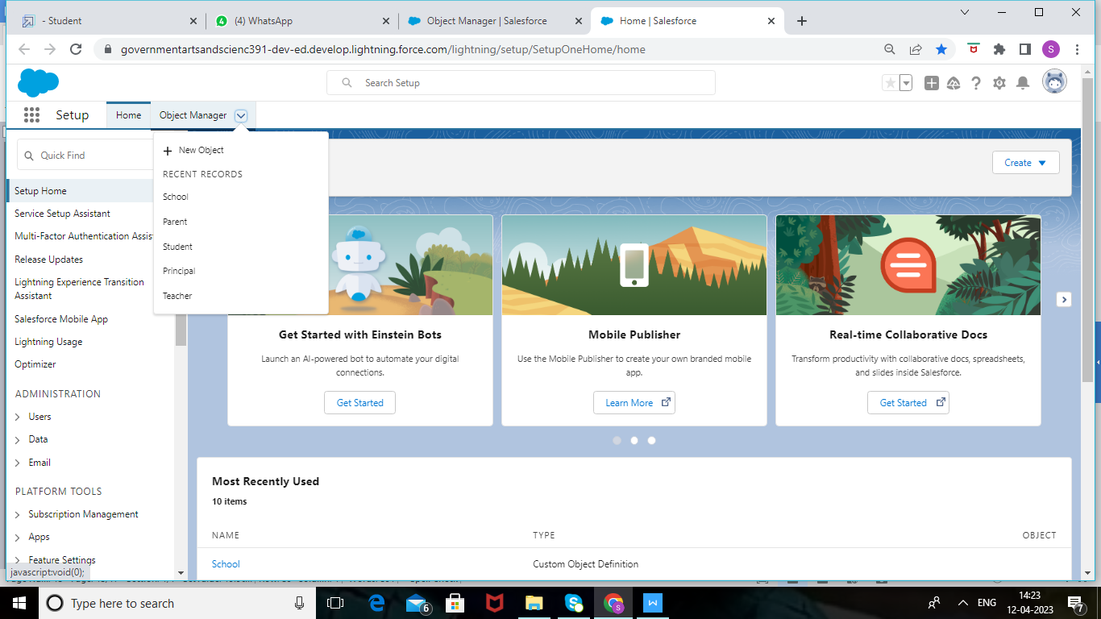

 Step 2

Select School.

Select Fields & Relationships from the left navigation, and click New

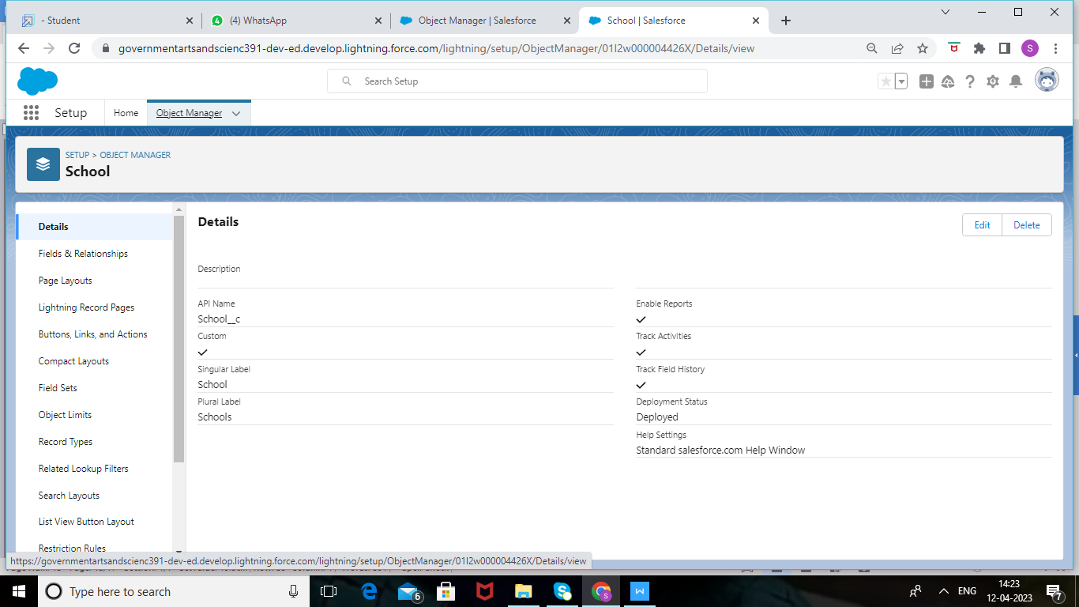

Now we're ready to make a custom field. Let's do this!

Select the Text Area as the Data Type, then click Next.

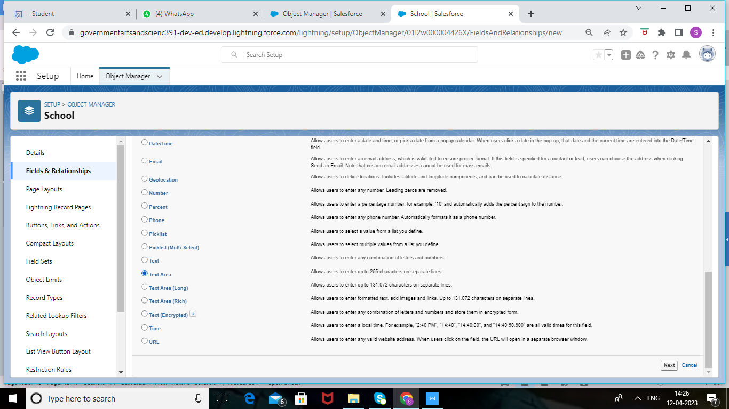

For Field Label, enter Address.

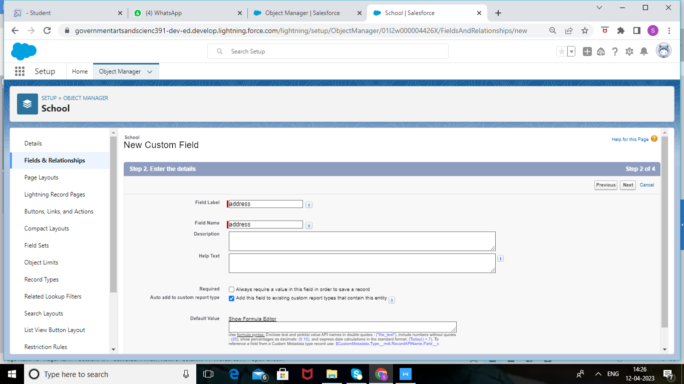

1. Click Next, Next, then Save & New.

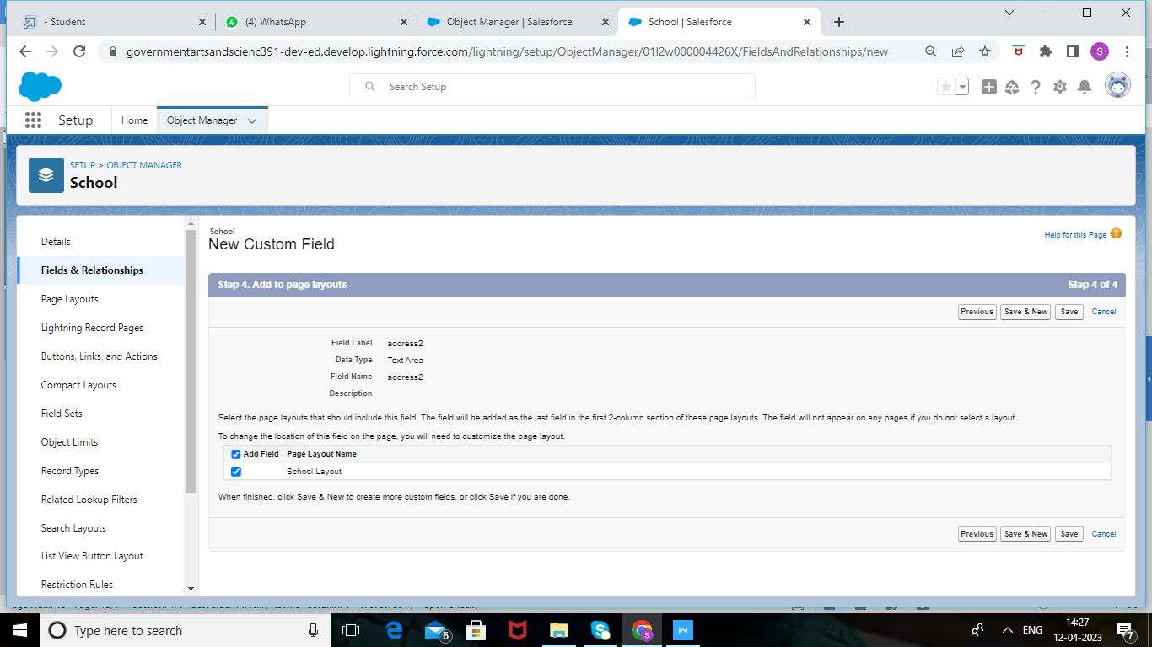

4. Follow steps 1 through 3 and create two more text areas with District,State and School

websites as the field label

Now let's create the other fields and we must choose the data types of the fields carefully .Let's

have a look at it.

For example, a phone number is a number field. For that we need to select the phone as data type.



1. Select the Phone as the Data Type, then click Next.

2. For Field Label, enter Phone Number.

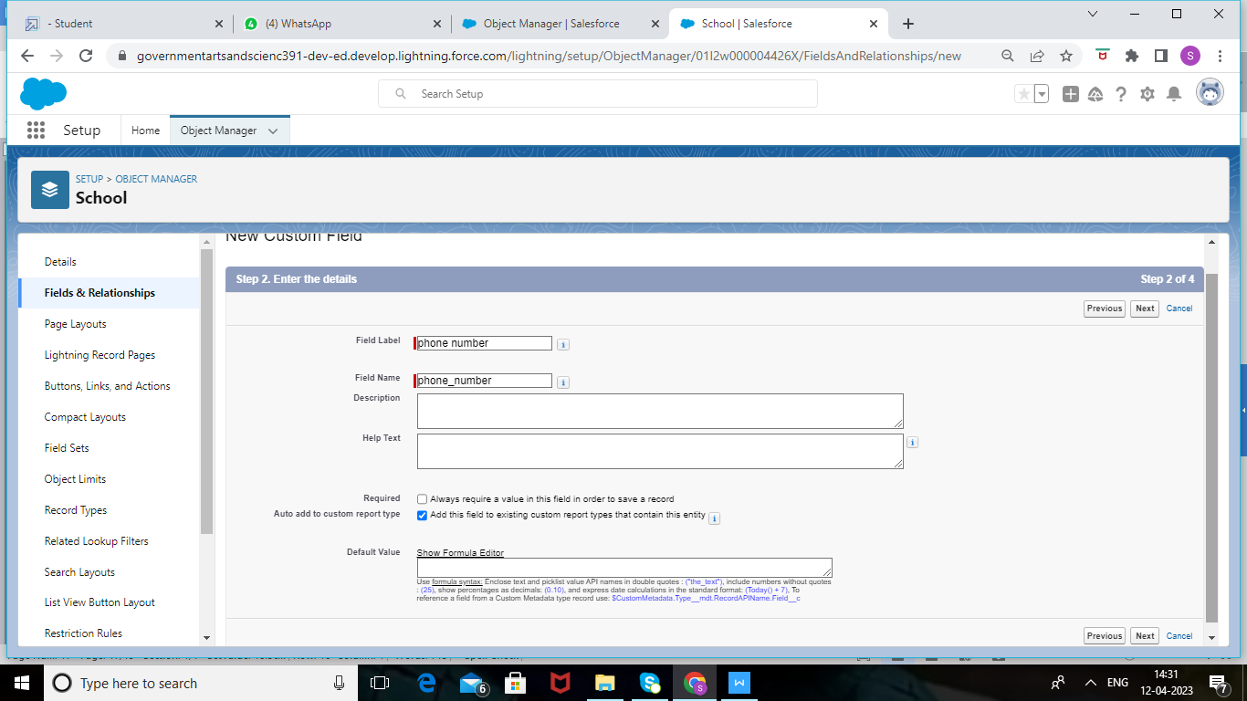

Click Next, Next, then Save & New.

Lets create Roll-up summary fields to calculate the number of students

1. From Setup, click Object Manager and select School.

2. Click Fields & Relationships, then New.

3. Select the Roll-up summary field as data type

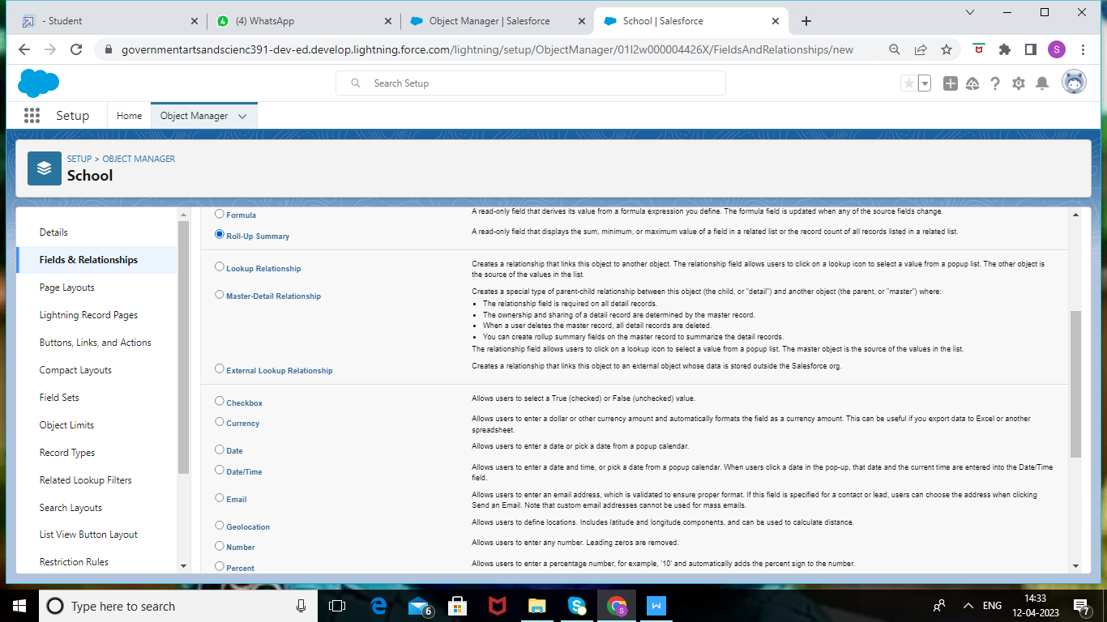

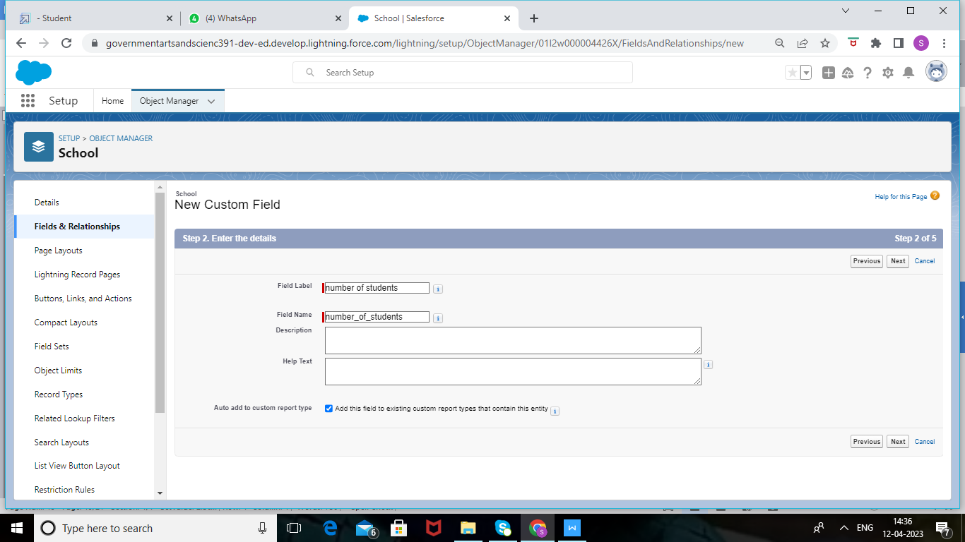

4. Enter the field label as Number of students

5. Click Next

6. Then select the master object summarized as students and then select count as roll-up and then click Next,Next and save.

1. From Setup, click Object Manager and select School.

2. Click Fields & Relationships, then New.

3. Select the Roll-up summary field as data type



Enter the field label as Highest Marks

Click Next

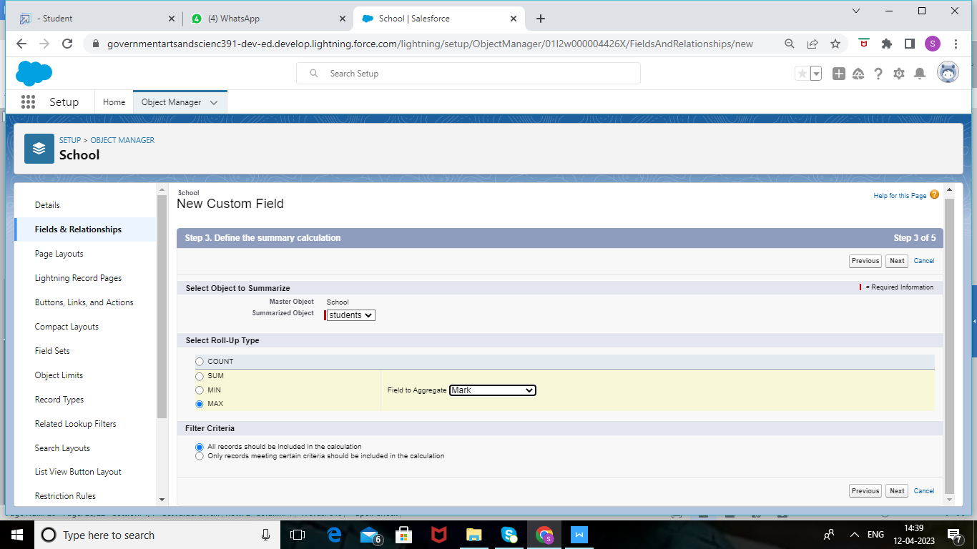

6. Then select the master object summarized as students and then select Max as roll-up and

then select Marks as field to aggregate. click Next, Next and save.

# Creation Of Fields For The Student Objects

1. Select the Phone as the Data Type, then click Next.

2. For Field Label, enter Phone Number.

3. Click Next, Next, then Save & New

Let's create a master-detail relationship with school object

Select Master-Detail Relationship as the Data Type and click Next.

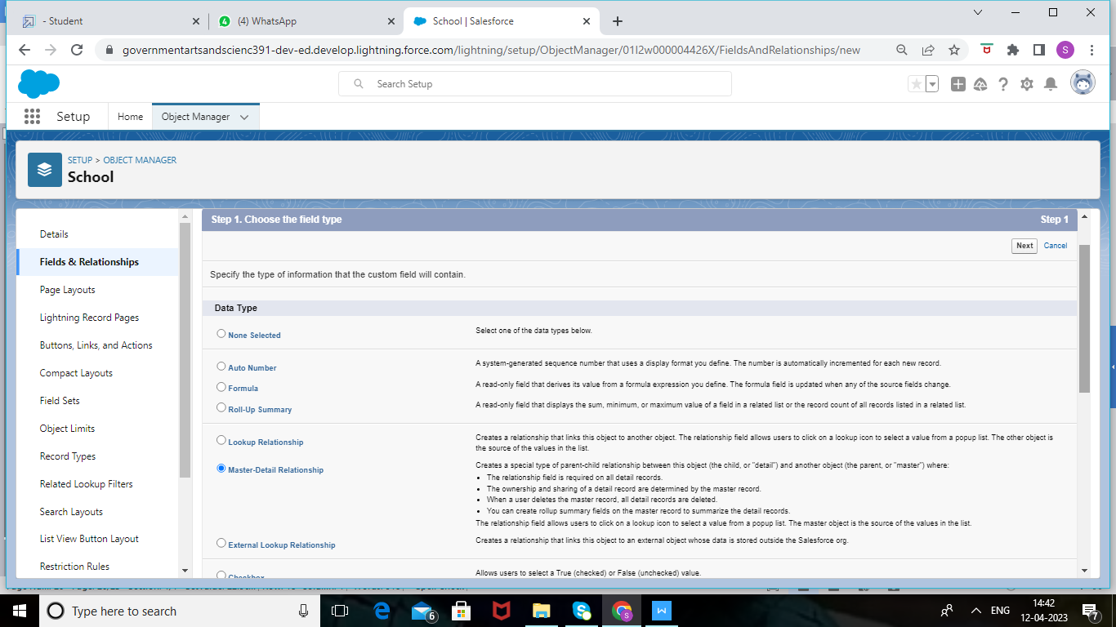

1. For Related to, enter School.

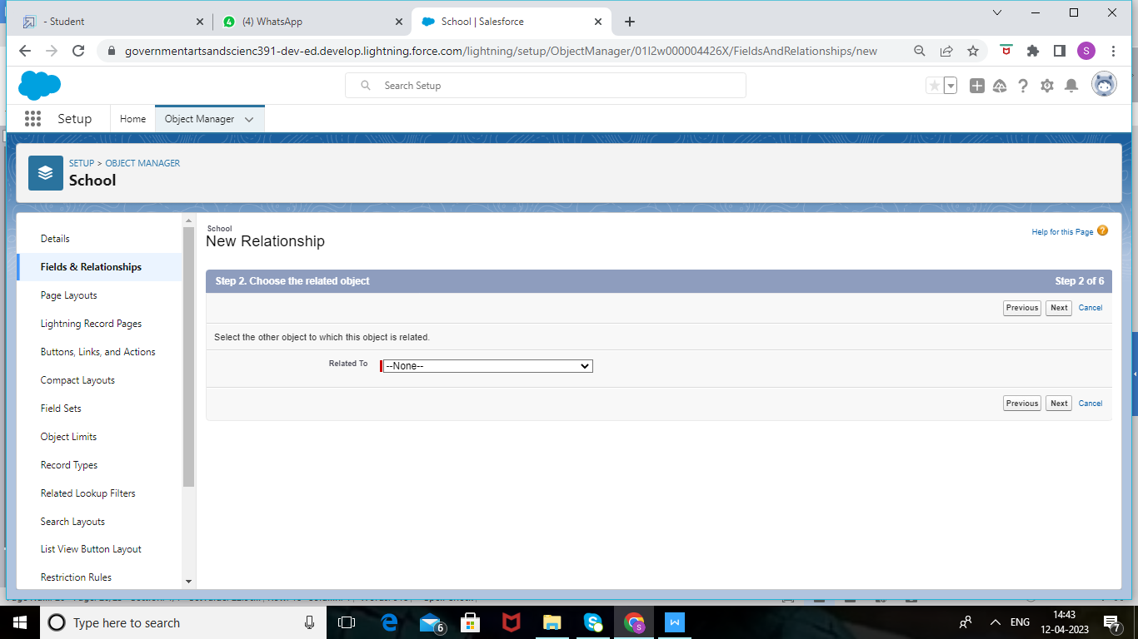

3. Click Next.

4. For Field Label, enter School.

5. Click Next, Next, Next and Save.

Lets create a Pick-List field:

1. From Setup, click Object Manager and select Student.

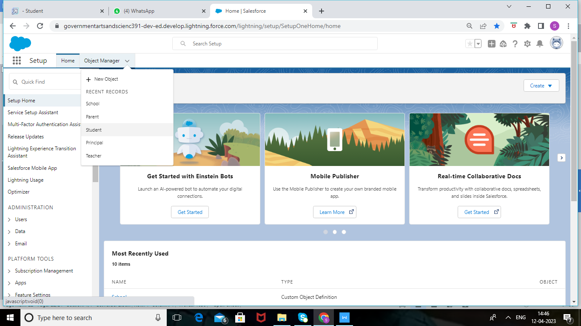

2. Click Fields & Relationships, then New.

3. Select Picklist as the Data Type and click Next

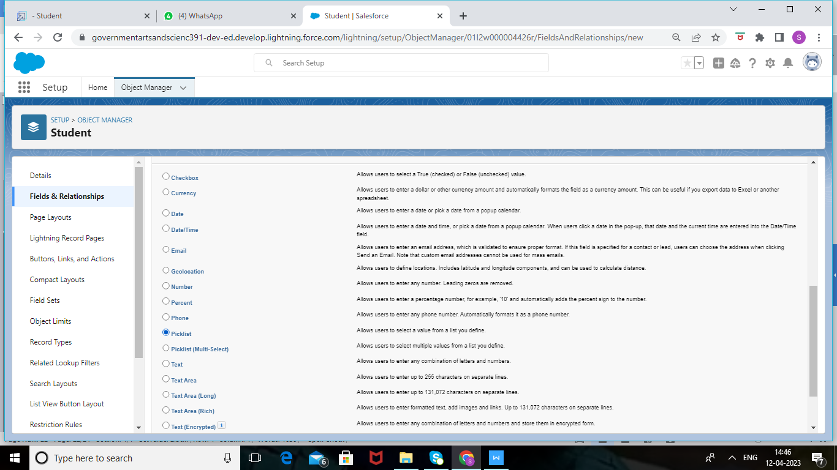

4. For Field Label enter Results.

5. Select Enter values, with each value separated by a new line and enter these values:

6. Pass

7. Fail

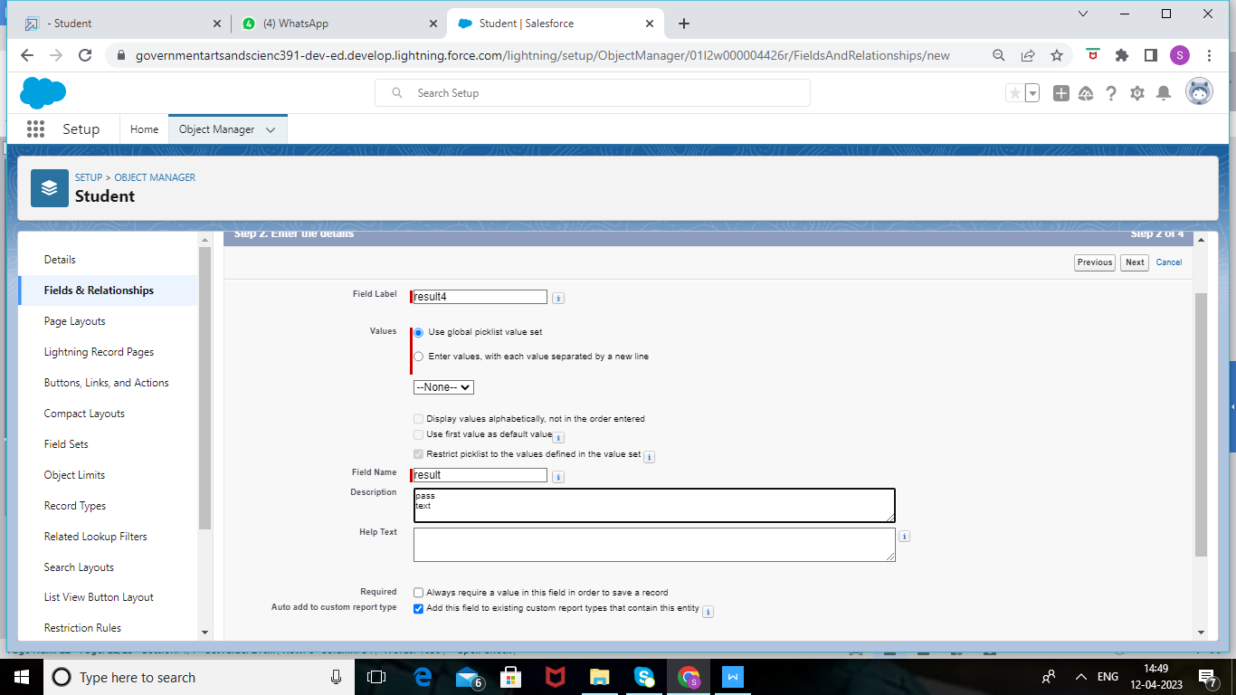

8. Click Next, Next, then Save & New

Lets create a Number field:

1. Select the Number as the Data Type, then click Next.

2. For Field Label, enter Class.

3. Click Next, Next, then Save & New

4. Follow steps 1 through 3 and create one more number field with Marks as the field labels.

# Creation Of Fields For The Parent Objects

1. Select the Text Area as the Data Type, then click Next.

2. For Field Label, enter Parent Address.

3. Click Next, Next, then Save & New.

4. Select the Phone as the Data Type, then click Next.

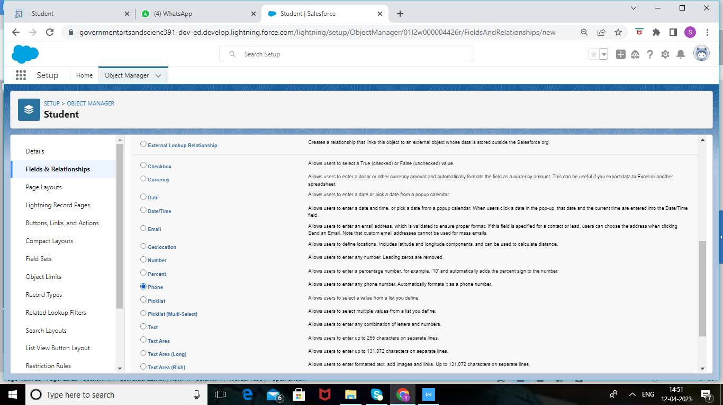

5. For Field Label, enter Parent Number.

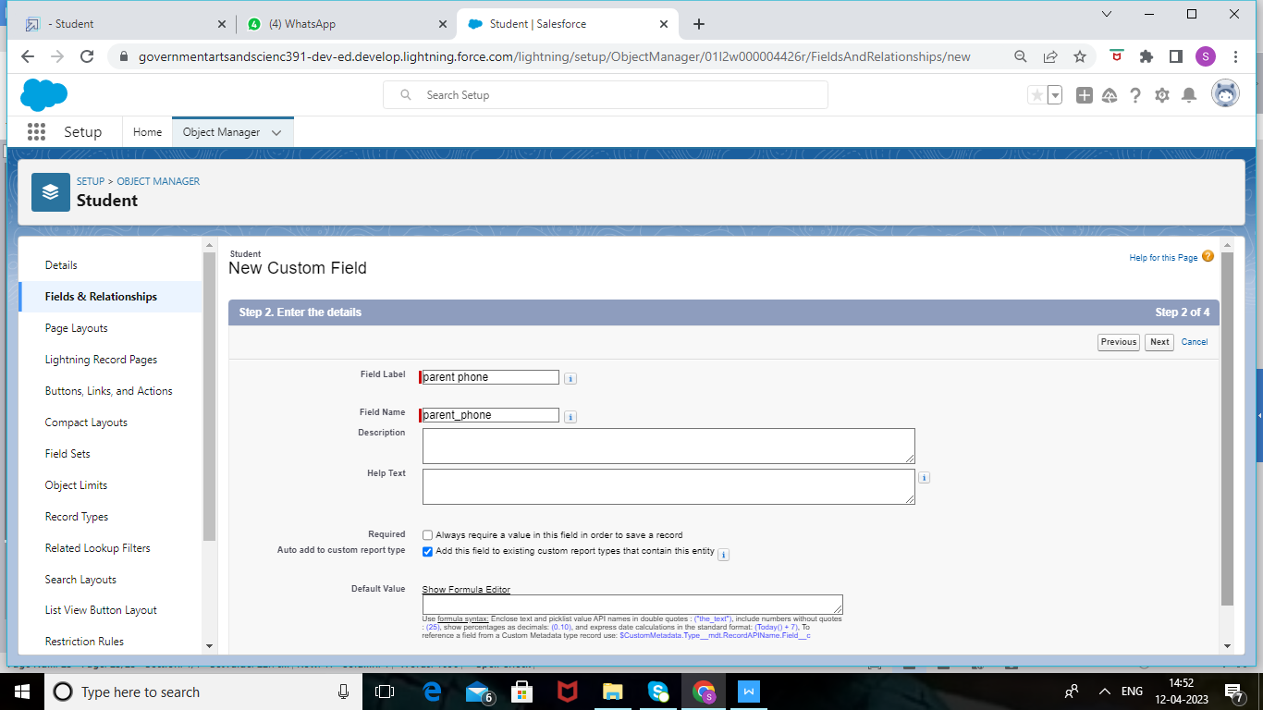

6. Click Next, Next, then Save & New

### **Creation On Profile**

From Setup enter Profiles in the Quick Find box, and select Profiles.

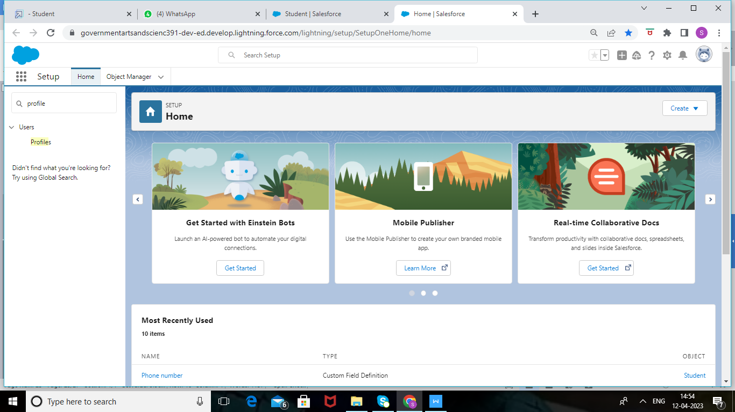

From the list of profiles, find Standard User.

1. 2. Click Clone.
2. 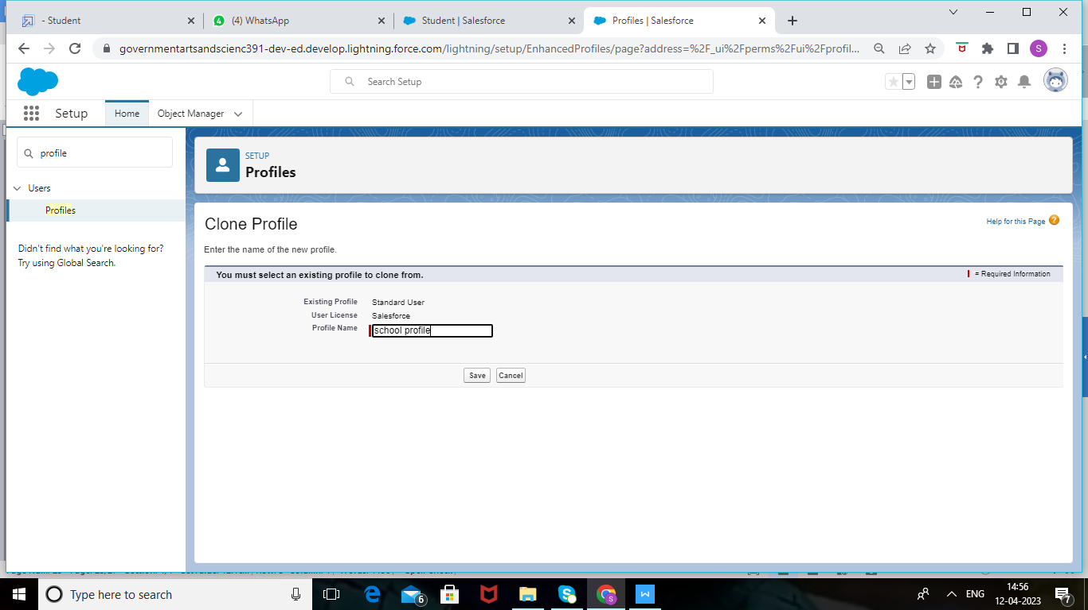

3. For Profile Name, enter School profile.

4. Click Save.

5. While still on the School profile page, then click Edit.

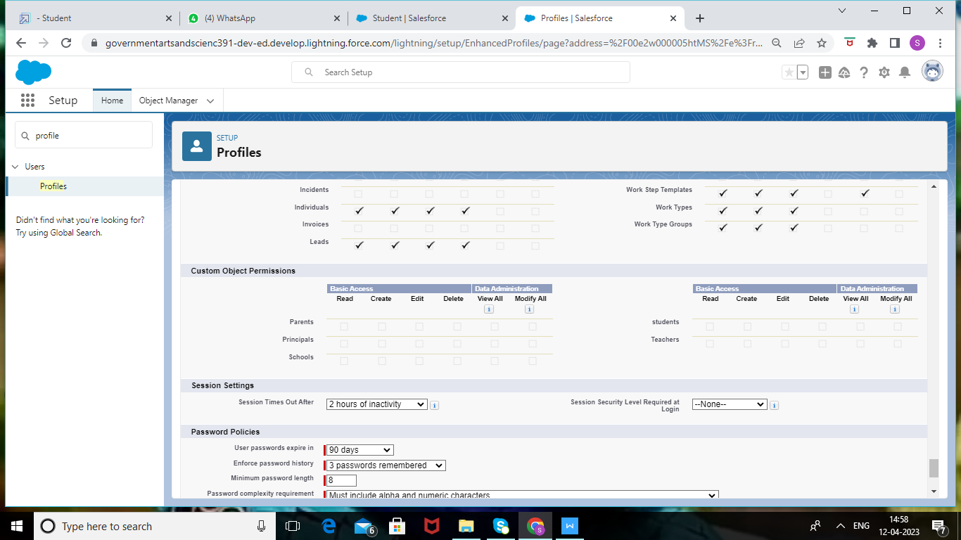

6. Scroll down to Custom Object Permissions and Give view all access permissions and

assign to the parent profile.

Creating A Users

From Setup, in the Quick Find box, enter Users, and then select Users.

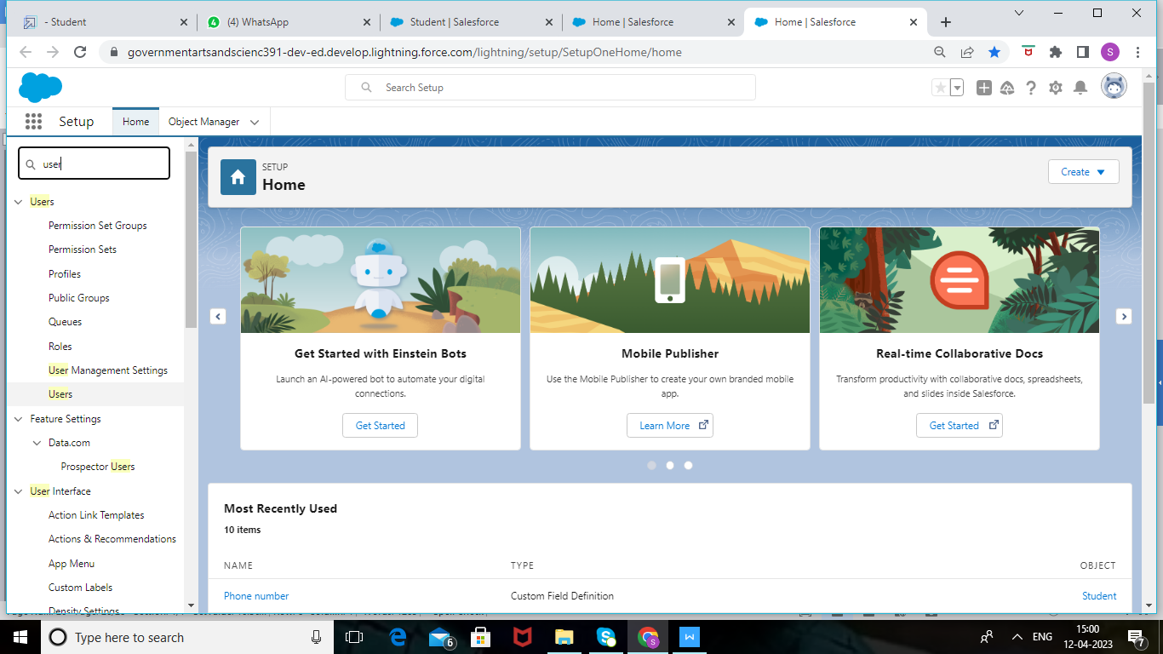

Click New User.

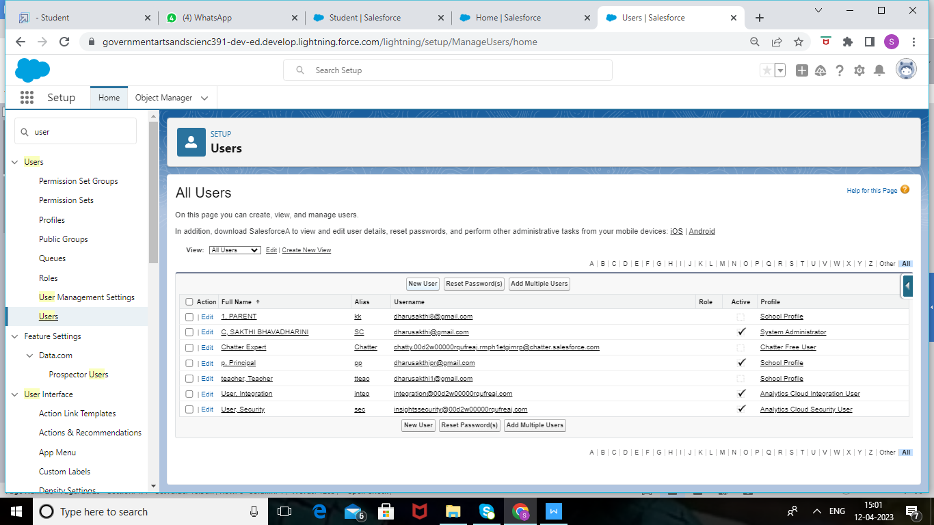

3. Enter the user’s name Parents and (Your) email address and a unique username in the form of an email address. By default, the username is the same as the email address.

4. Select a User License As salesforce.

5. Select a profile as a School profile.

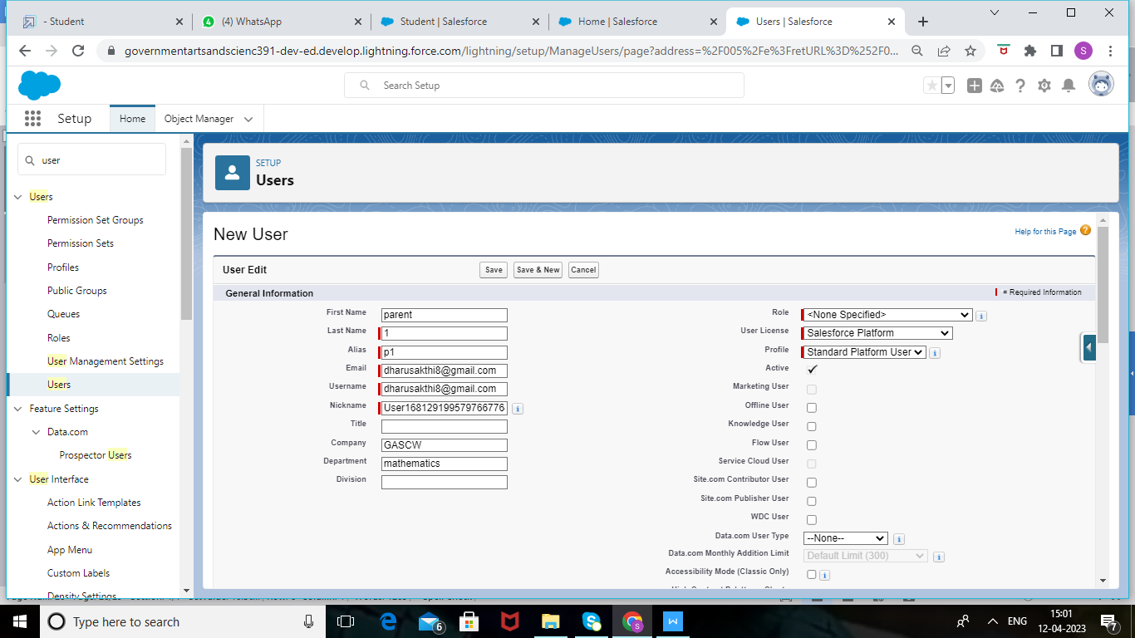

6. Check Generate new password and notify the user immediately to have the user’s login name and a temporary password emailed to your email.

7. Similarly follow the above steps and create 3 users as Teachers and principals.

# Permission Sets 1

From Setup, enter Permission Sets in the Quick Find box, then select Permission Sets.

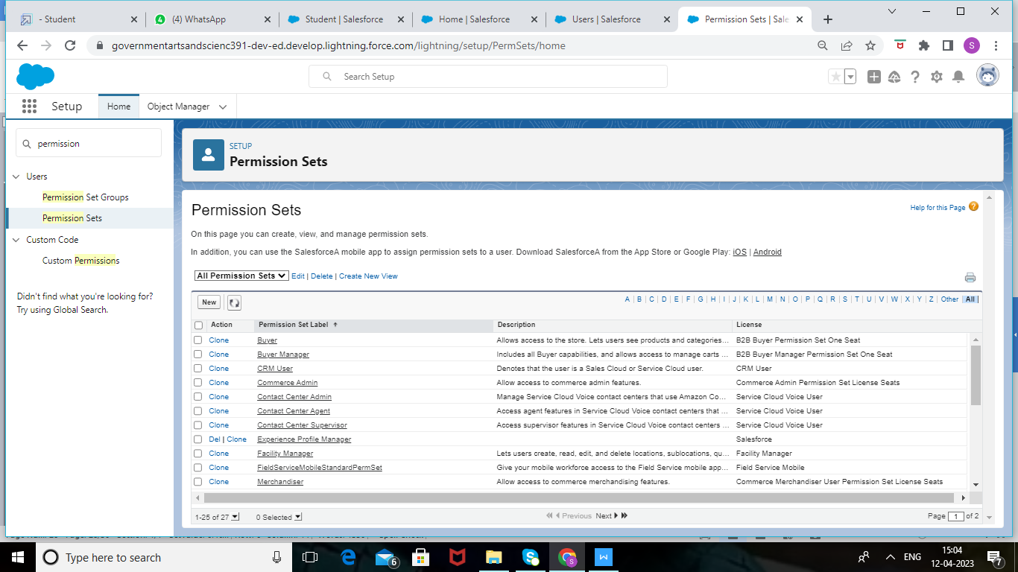

Click New.

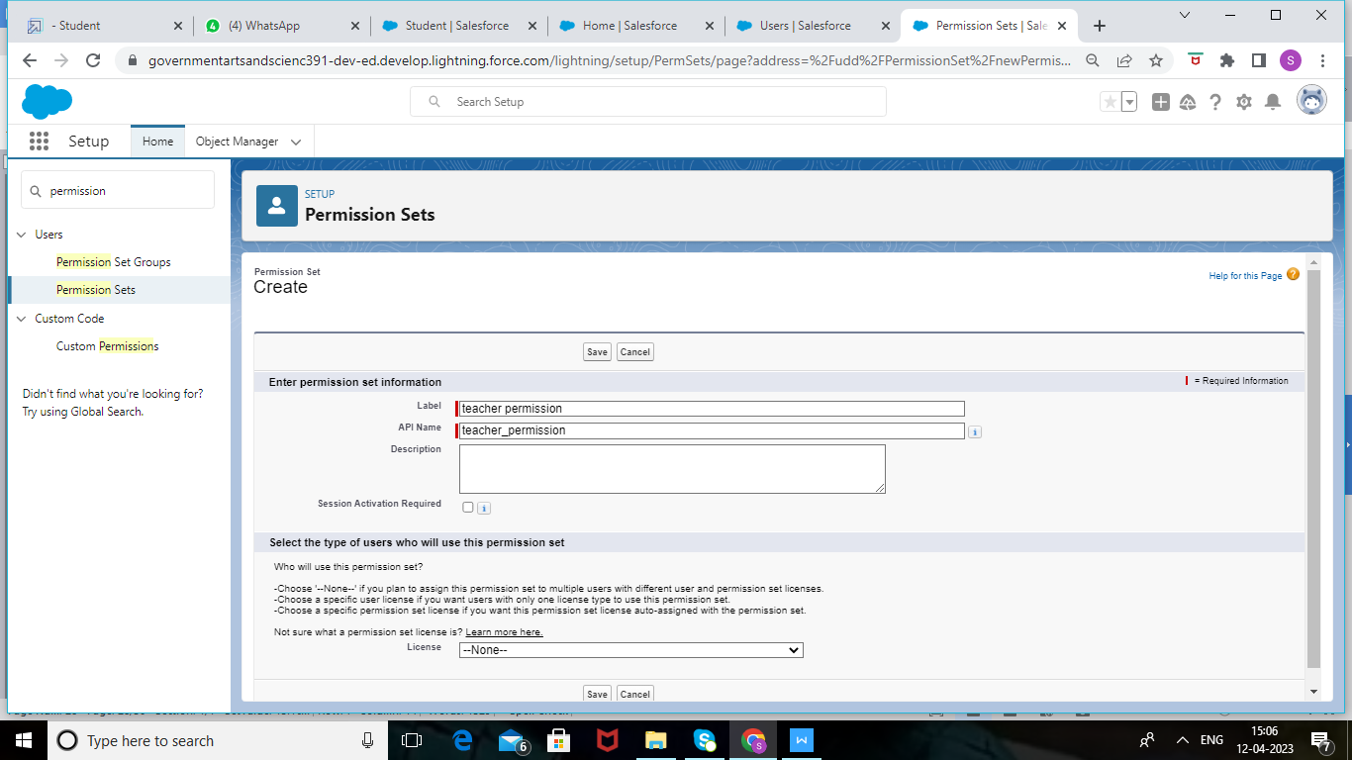

3. Give the name of the Permission set name as teacher permission and then under the object settings give the view create and edit permissions to all custom objects and assign to the teacher user  
  
Similarly follow the above steps for the permission set 2.

# Permission Sets 2

1. From Setup, enter Permission Sets in the Quick Find box, then select Permission Sets.

2. Click New.



3. GIve the name of the Permission set name as Principal permission and then under the object settings give all permissions for the custom objects and assign them to the Principal user.

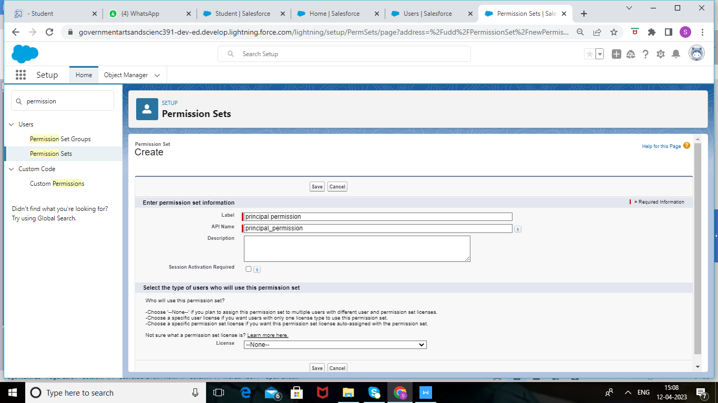

# Reports

click appmanager ,choose report.

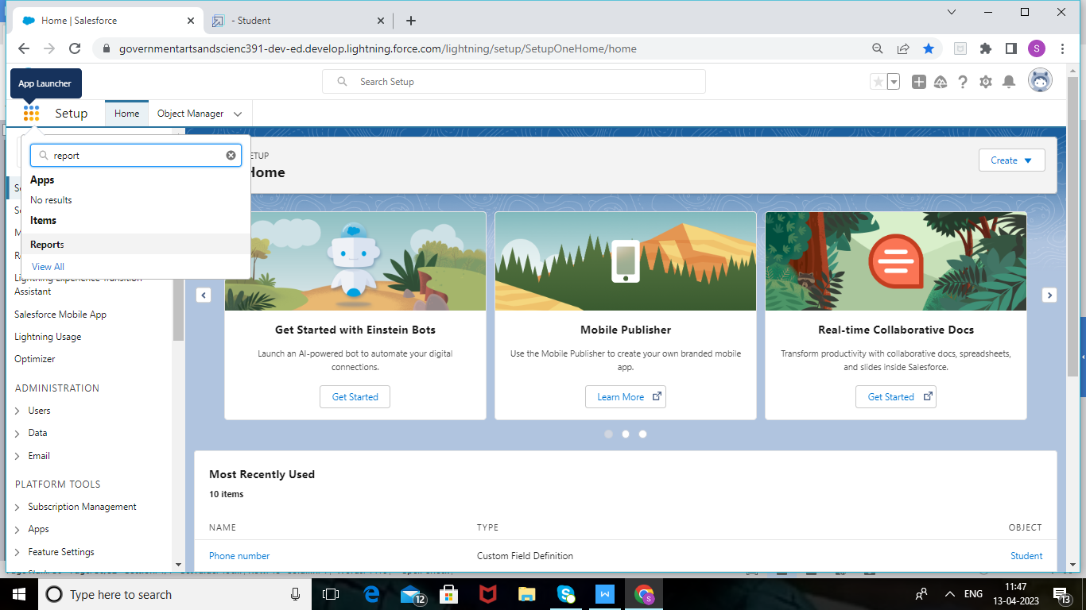

From the Reports tab, click New Report.

2. Select the report type as School with students and parents for the report, and click Create.

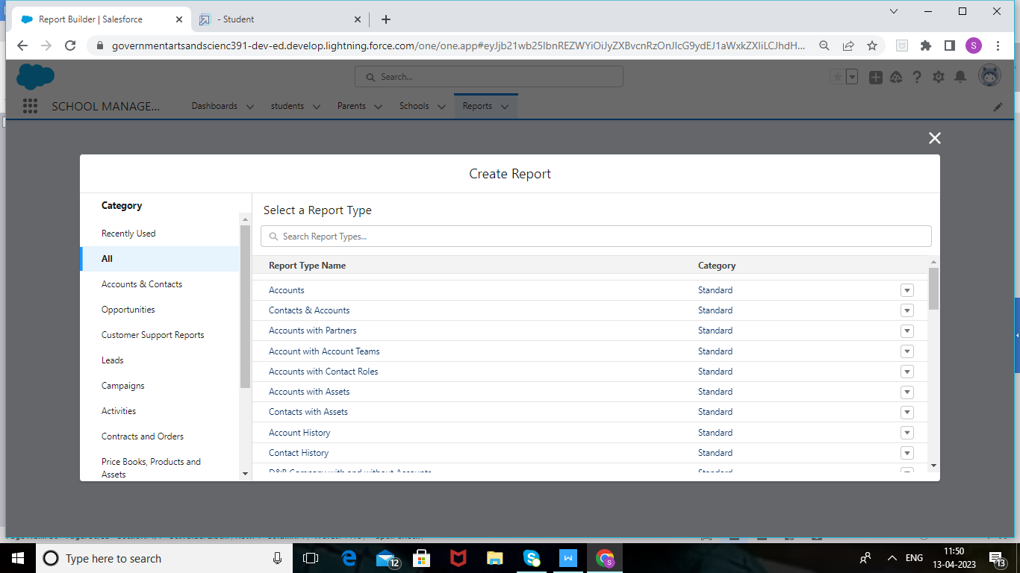

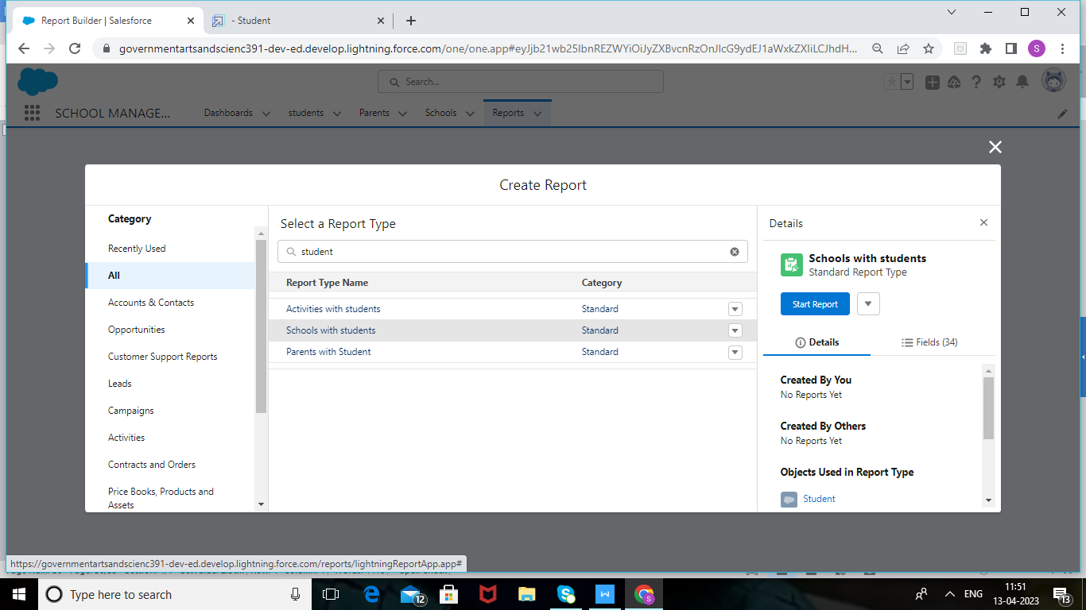

3. Customize your report, then save or run it.

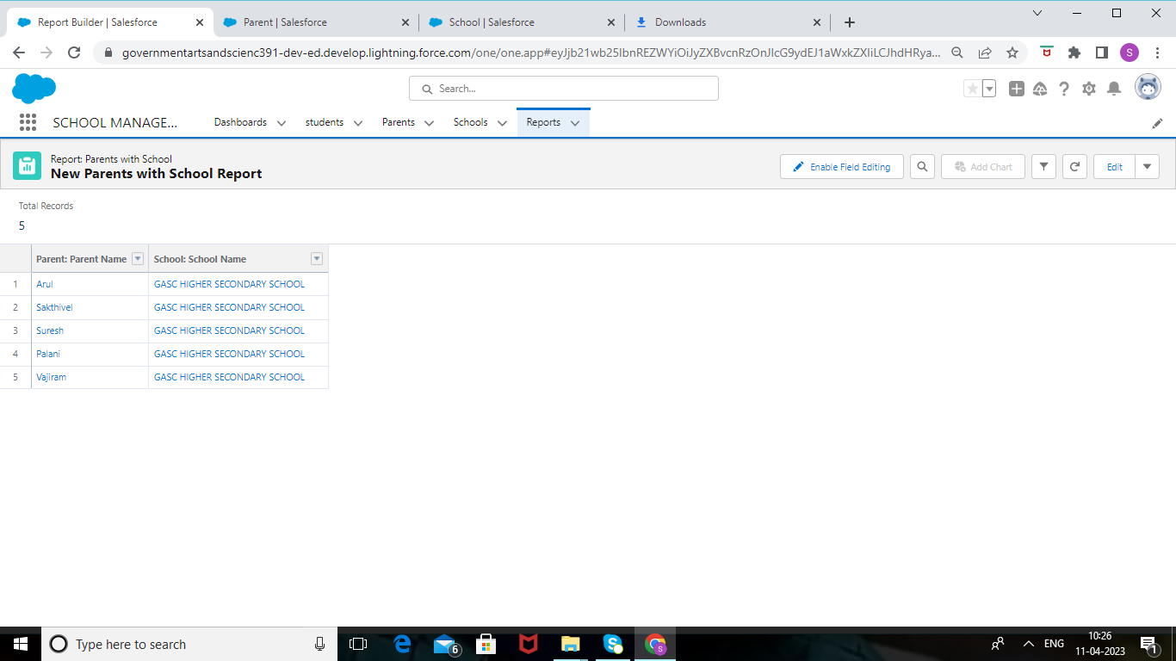

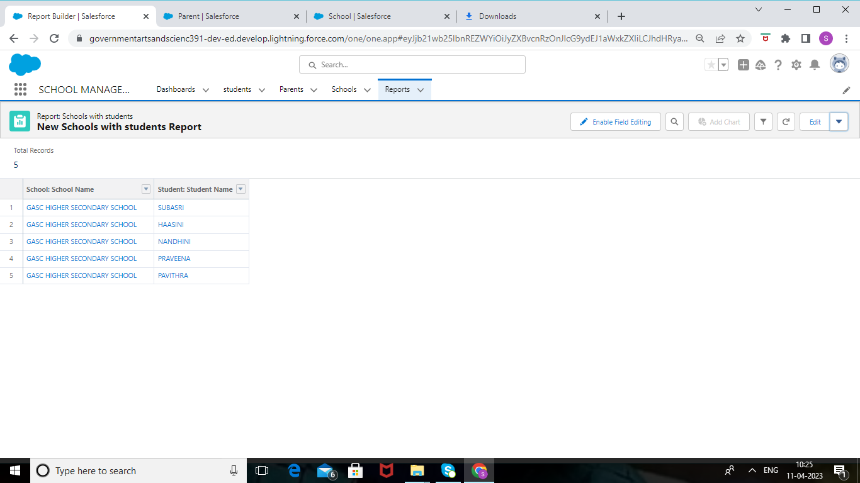

4 TRAILHEAD PROFILE PUBLIC URL

TEAM LEAD -https://trailblazer.me/id/sbhavadharinic

TEAM MEMBER 1-https://trailblazer.me/id/svajiram

TEAM MEMBER 2-https://trailblazer.me/id/tthraviya

TEAM MEMBER 3-https://trailblazer.me/id/subas179

5 ADVANTAGES AND DISADVANTAGE

* CRM usage in higher education has a wide range of powerful benefits.
* Education CRM application are meant to automate and manage communication with students ,employees and in the school/institution.
* It enables schools to track interactions with students and their parents ,and provides a platform for personalized communication.
* With all data stored in one place,schools can gain valuable insights into student behaviour ,preferences,and trends.this information can be used to make informed decisions about admission processes , student engagement , and resource allocation.
* Schools can also use the data to monitor students progress and identify areas for improvement.
* Tracking of school vehicles by parents .
* Communicating with teacher is more easier.
* It provides globalized and high competitive environment to students and parents.

Disadvantages

* Having lots of security concerns .
* Increased screen time for students and parents.
* Technology is good, but it is also distractive . students today are smart enough to find backdoors in school system to surf the web or play games instead of learning.
* There are many security issues , such as data loss and data being hacked by someone.

APPLICATIONS

Since CRM is a helpful software for businesses and customers, it is widely used in most industries apart from the ones listed above. Some of these include:

* Healthcare
* Agriculture
* E-commerce
* Legal industry
* Fitness industry
* Marketing
* Telecommunication
* Travel and tourism
* Real estate
* Call center

# CONCLUSION

Today,a good customer relationship management(CRM) platform is the backbone of many successful student recruitment efforts.

A CRM system with a mobile application for a school.in the course of the work,the processes of modeling,building architecture,and implementation of web application functionality were described.

Customer relationship management solutions are required in the education sector to make fast, dynamic, and affordable solutions that make it easy for universities to handle daily activities. The CRM gives a proper understanding of the students and activities carried out in the university. It also lets students communicate with the university.

In a custom CRM for a university, students get information about enrollment, registration, financial help, accommodation, and so on. They are considered as the customers, and the goal is to provide top-quality services to students.

With CRM solutions, universities can manage their students effectively. CRM also collects the management records such as student attendance, course curriculum, extracurricular activity records, and so on. It also maintains data privacy by automating processes. By analyzing the CRM information, solutions to problems can be found.

A CRM increases productivity, allows communication between students and alumni, and reduces administrative tasks in the education industry. Eventually, it helps the institute to establish itself as a brand in the crm.

A CRM is a customer - centric system that can help education professionals nurture relationships with prospects and enrollees, produce data-driven insights to illustrate progress towards goals,and streamline their admissions and marketing intiatives to save time and effort.

Schools apps adds flexibility to the learning process,mobile learning offers great opportunities for education, especially for teenagers,who show great attentiveness to mobile technologies.

# FURTURE SCOPE

## Constantly Survey the Business Environment and Your

## Business Model for Disruptive Technology

# Use Mass Personalisation Through Relevant Data

# Set KPIs Around Important Customer-Oriented Processes to Achieve Consistent Results

# Manage by Exception to Refine Processes and Ensure Better Results.

# Understand Profitable Customers and Customer Referral Value